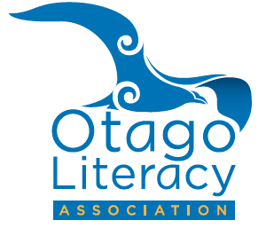

2017 Membership

1st January 2017 – 31st December 2017

Membership: Early Childhood/U1 &2 = $60; U3 & 4= $70; U5+= $90
College Students/PR Teacher = $20

Name of School/ECE Setting _____________________________________________________

Full Postal Address _____________________________________________________________

Telephone ________________________________

Name of nominated contact member (Essential)______________________________________

Email (Essential)__________________________________________

……………………………………………………………………………………………………………………………………….

2017 Personal Membership $50.00

Name _________________________________________________

Full Postal Address _____________________________________________________________

Telephone __________________________________

Email (Essential)________________________________________________________________

Position held ___________________________________________________________________
Make cheques payable to: Otago Literacy Association (OLA)

Please complete this form and send it with a cheque to:

The Treasurer, OTAGO LITERACY ASSOCIATION. Box 6304, Dunedin

Internet Banking: Account Westpac 03 0903 0385685 01
Reference: Your name, Organisation name, OLA Subs
Peta Hill

Office Use: Payment received | Internet / Cheque

