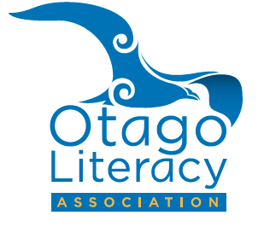
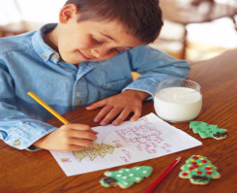
Kia mataara! Kia kakama! Maraka! Maraka!
Attention: Keen Writers!
Tuhi Pūrakau/Story Writing / Tā Pikitia/Picture Competition for Early Childhood & Primary Years 1-8.
He pānui tēnei ki ngā kura katoa me ngā whare kōhungahunga
Invitation to all Member Otago Schools, ECE Centres & Kindergartens to enter (no more than 3 per year group)
BY Wednesday 5 July
All work remains the property of the Otago Literacy Association and will not be returned to writers. No late entries will be accepted.

1st and 2nd prizes will be awarded to each year group. Stories are limited to 500 words, scanned and submitted as a pdf on-line to otagoliteracy@nzla.org.nz

Prizegiving: Meet Mere Whaanga University of Otago CNZ Children’s Writer in Residence, which will take place at 4.30pm on Thursday 3 August at the Robertson Library foyer, Union Street, Dunedin.
Winners will be notified through their schools and centres. Parents are welcome to attend prizegiving.

Please complete this form and attach to each story entered.

Name……………………………………………………………………………………………….

Year Group……………………………………

School / Centre………………………………………………………………………………….

Contact Person…………………………………………………………………………………

