 | Marie Clay Literacy Trust Teacher’s Awards | 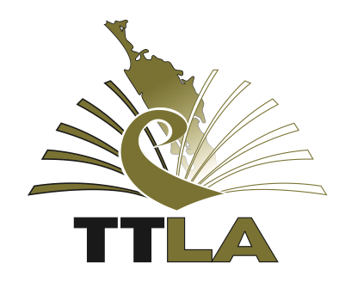
TTLA in conjunction with The Marie Clay Literacy Trust invite you to apply for 3 awards towards attending the upcoming New Zealand Literacy Association 42nd National Conference in Christchurch from 29th September – 2nd October 2019
“The Arts as a Bridge to Literacy”
Marie Clay Literacy Trust - Early Careers Teacher Award
$1000 for teachers with up to and including 6 years teaching experience.
Apply to taitokerauliteracy@nzla.org.nz by Friday 12th April
Marie Clay Literacy Trust Experienced Teacher Award
$1000 for teachers with more than 6 years teaching experience
This is award combines $500 from Marie Clay Literacy Trust plus $500 TTLA Contribution.
Apply directly to NZLA – submit your application electronically as detailed in the attached application form by Monday 29th April 2018.

Tai Tokerau Literacy Association Conference Award
$1000 for all teachers in Tai Tokerau.
Apply to taitokerauliteracy@nzla.org.nz by Friday 12th April
All awards cover the cost of registration and accommodation / travel to a total of $1000.
To apply for an award
Write a submission outlining how the award would be of benefit to you.
Provide the name and phone number of a referee who is a leader in your school.
Agree to provide verbal or written feedback to the TTLA committee about your experience and learning from the NZLA National Conference.

