President’s Report 2020
Hawke’s Bay Literacy Association
I present this report after being president for one year, 2019/2020.

The Hawke’s Bay Literacy Association has enjoyed another busy and productive year with our hard working committee always on the look-out for ways to promote literacy learning in our region.

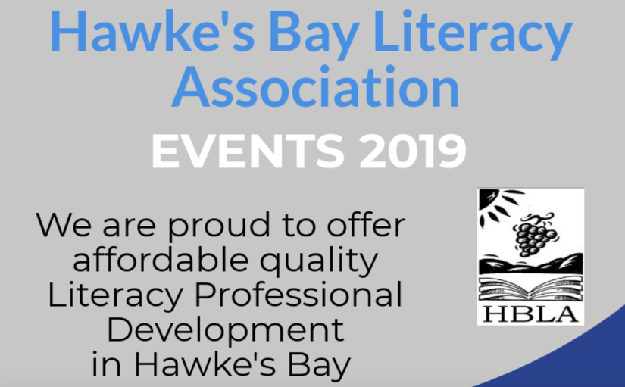
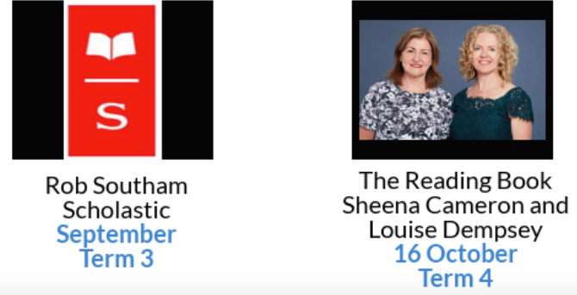
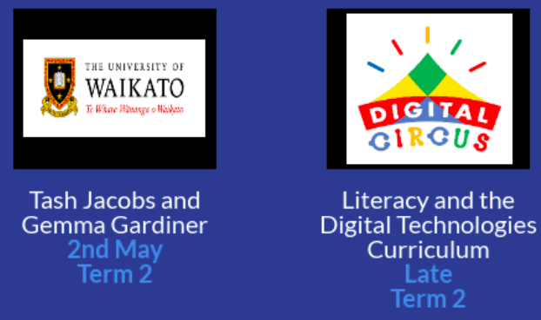

“Literacy is the means through which every man, woman and child
can realize his or her full potential.”
Kofi Annan

Term Events
- For our first event of the year, we welcomed the ‘Dynamic Duo’ of Gemma Gardiner and Natasha Jacobs, experienced Literacy facilitators, mentors and coaches from Te Whai Toi Tangata (University of Waikato). Gemma and Tash shared practical, hands-on, fun ideas for writing that teachers could immediately implement into their classroom programmes. This event at the Havelock North Community Centre was a sell out which is a testament to the quality of our two dynamic presenters!

- Later in Term 2, we hosted Juliet Revell and Toni Westcott from Digital Circus at Taradale Primary School. Fresh out of the classroom, Juliet and Toni provided a wealth of new ideas and concepts from the digital curriculum. They have extensive knowledge of how to effectively teach digital literacy in our classrooms. We were able to practise these skills at the session, and teachers felt inspired to put their new-found skills into action.

- In Term 3, we welcomed Rob Southam to the Bay. Rob is an ambassador for Scholastic Books. She shared the current trends, and ‘new reads’ for our children. Rob’s passion for literature was received with enthusiastic support by our members. Her recommendations were of particular interest to the school librarians that attended the event.

- Our final event for the year launched the latest book by Sheena Cameron and Louise Dempsey, “The Reading Book”. The workshop, held at Lindisfarne College, reviewed the approaches in balanced reading programmes, while also providing an overview of the chapters, including take-away strategies, ideas and activities. What an inspiring and practical workshop. ‘The Reading Book’ should be a ‘must read’ for all teachers! This event was attended by over 200 educators. Sheena and Louise are generous in their support of our NZLA councils.

Scholarships and Donations
- We were delighted to award three scholarships this year that supported members to attend the National Literacy Conference in Christchurch.
- We have made substantial book donations to the Children’s Ward at the Hawke’s Bay Hospital, and to Plunket.
- A new HBLA scholarship of $500 was awarded to an EIT Bachelor of Teaching student. Amy Kochelburg was excited by this opportunity to buy literacy related texts and resources. We anticipate that this scholarship will be awarded annually.

Administration
Considerable progress has been made over the past year with administration of finances and reporting of these. Diane Harris has worked tirelessly to update our systems and procedures in banking, invoicing and monthly reports. Using Xero has proved to be a very worthwhile initiative and the committee acknowledge and are very appreciative of the work that Diane and her daughter, Emma Harris have put into developing these new procedures. Our grateful thanks go to them both.

NZLA
In the first term Leigh Johnson, Annette Geddis, Gayl Squire and I went to the NZLA Leadership workshop in Feilding. This was a very worthwhile day of networking, learning and planning. We enjoyed the opportunity to meet and work more closely with the Executive and members of other councils.
Leigh (NZLA Delegate) and Annette (Vice President) attended the NZLA Annual Meeting in Wellington in June. They gained a lot from this experience.

We are looking forward to another year of building our membership and organising exciting professional learning events. Planning is underway for the New Zealand Literacy Association Conference in Hawke’s Bay in October 2021.
Thanks to our hardworking HBLA committee who work very hard to organise events and undertake charitable activities - you are the people who keep our local council an active and successful network of educators.

Jane Taylor
President
