A New Zealand Histories Resource for NZ Educators
How, what, why about NZ history
Presenter: Tamsin Hanly

The Summer Learning Journey Programme
A digital solution to a persistent problem?
Presenter: Dr Rachel Williamson-Dean

and AGM

Auckland Literacy Association
Presents

A New Zealand Histories Resource for NZ Educators

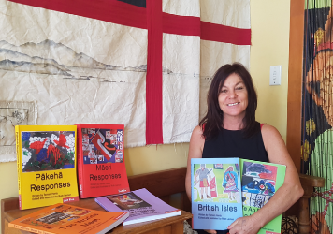
Tamsin Hanly is a lecturer at The University of Auckland, in the Faculty of Education & Social Work, Maori Department. She has worked in and around Maori and mainstream education since 1986. In 2007, she completed her Masters with First Class Honours titled ‘Preparing students for bicultural relationships’. Tamsin will be presenting her curriculum programme resource for schools and teachers on New Zealand Histories. Tamsin suggests it is a critical guide to Maori and Pakeha histories of Aotearoa.

The Summer Learning Journey Programme

Dr Rachel Williamson-Dean is a Post-Doctoral Research Fellow, working full-time in the field of literacy education at the Woolf Fisher Research Centre, The University of Auckland. Rachel is passionate about working with vulnerable populations to realise positive outcomes. Rachel’s current research project, The Summer Learning Journey is a multi-year national study focussing on digital literacy learning for primary school students over the holiday period.

Evidence from existing national and international literature suggests that students’ can experience a slide or slump in their literacy learning over the summer holiday period. This decrease has been termed the ‘Summer Learning Effect (SLE).’ Educators and researchers in New Zealand have come together to try and address the SLE through the introduction of a digital literacy (blogging) programme - the Summer Learning Journey (SLJ). Dr Rachel Williamson-Dean will share the insights that she and her team have gleaned over the past few years in three specific areas – programme design, implementation and evaluation.

YOU MUST SEND THIS PAGE TO CONFIRM YOUR REGISTRATION aucklandliteracy@nzla.org.nz
or post to: Alarna Sutton, Treasurer
Auckland Literacy Association
c/o Papatoetoe West School
1 Hillcrest Rd
Papatoetoe 2025

Where: Owen Gilmore Theatre, University of Auckland Epsom Campus, N block, level 6 Room 614

Parking: Venue Location & Parking http://bit.ly/2RYw06O

When: Wednesday 4th March 2019

Time: 4.30-6.00pm Refreshments available from 4.00pm

Cost: ALA members – free
Non-members $20

RSVP: Friday 28th February to akldlitassoc@gmail.com

Payments to: Auckland Literacy Association
Bank: ASB 12 3047 0068110 00 Reference: your name or school name
Member Schools can send five teachers at member price.
All others need to pay non- member price.

School Name
Contact email
Attendee Names

