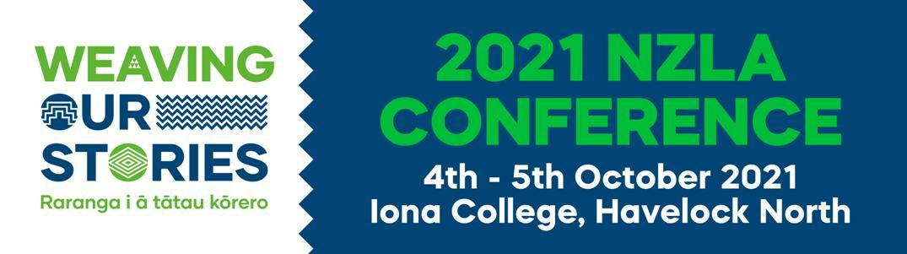
WORKSHOP SUBMISSION
Thank you for your interest in presenting a Workshop at the 2021 NZLA Conference.
Please complete the attached Workshop Submission Form, giving as much information as possible to help give the selection panel the fullest picture possible about the Workshop you are offering.

Return completed Submission Form to: hawkesbayliteracy@nzla.org.nz

If you have any questions regarding your submission, please contact:
Jane jtaylor@napiercentral.school.nz or Gayl gayls@taraprim.school.nz

The over-arching themes for the Conference Workshops are:

- Weaving our Stories of Aotearoa - differing perspectives and contexts
- Love of Literacy - inspiring our students with a love of literacy and learning - engagement, authors, illustrators, creativity, rich literature, digital literacy, poetry…
- Sharing our practice-based inquiries and research - including spiral of inquiry, NZLA research, Kāhui Ako research…

Terms and Conditions:

- All workshops are to be an hour duration
- Workshops submissions close Friday 28 May 2021
- All workshop submissions will be notified of acceptance or otherwise by Friday 23rd July 2021
- Workshop presenters will have to be fully registered attendees at the conference.
The Marie Clay Literacy Trust Conference Workshop Presenter Grants
All non-commercial NZ based Workshop presenters will be eligible to enter a draw for one of five $1000 Grants.
The draw will be supervised by the Conference committee.
The Marie Clay Literacy Trust will not engage in any correspondence.
Grant recipients will be announced at the closing of the conference.
WORKSHOP SUBMISSION FORM
TITLE |  |  | FIRST NAME |  |  |  |  | SURNAME
EMAIL
MOBILE
SCHOOL / INSTITUTION / BUSINESS
POSITION IN SCHOOL / INSTITUTION / BUSINESS
NZLA Membership  (highlight one that applies) |  |  | Individual |  | School/Institution |  | Name of Council |  |  |  | None
 |  |  | Other (please indicate)
Conference Workshop Theme that applies  (highlight all that apply) |  |  | Weaving our Stories of Aotearoa |  |  |  |  |  | Love of Literacy
 |  |  | Sharing our practice-based inquiries and research
Workshop Title
Workshop Brief Overview (less than 50 words)

Workshop Detail:

Workshop Submission CLOSE – Friday 28th May 2021
Workshop Submissions notified – Frisdy 23rd July 2021
Workshops Announced – Monday 26th July

Return completed form to: hawkesbayliteracy@nzla.org.nz

